

**ADIGRAT UNIVERSITY**

**COLLEGE OF ENGINEERING AND TECHNOLOGY**

**DEPARTMENT OF SOFTWARE ENGINEERING**

**FINAL GRADUATING PROJECT DOCUMENT ON**

**ONLINE EMPLOYEE AND EMPLOYER INTERCONNECTION WEBSITE**

A PROJECT DOCUMENT SUBMITTED TO THE DEPARTMENT OF SOFTWARE ENGINEERING OF ADIGRAT UNIVERSITY IN PARTIAL FULFILMENT OF THE REQUIREMENTS FOR THE DEGREE OF BACHELOR OF SCIENCE IN SOFTWARE ENGINEERING.

**MEMBERS OF THE GROUP**

**NAME ID-NUMBER**

1. **HAFTAY DESTA RET/10473/11**
2. **GUESH GOITOM RET/11771/11**
3. **HIRUT TESFAY RET/14555/11**
4. **LIDAY ERMIASE RET/14444/11**
5. **HAYAT TUEM RET/06456/10**
6. **G/TSADIK BRHANU RET/10585/11**

**Advisors: Ins. ZEMIKAEL (MSc)**

**Adigrat, Ethiopia, January, 2016E.C**

## EXECUTIVE SUMMARY

**PROJECT TITLE:  ONLINE EMPLOYEE and EMPLOYER INTERCONNECTION WEBSITE**

The "Online Employee and Employer Interconnection" research proposal aims to develop a user-friendly and efficient online platform that overcomes the limitations of manual and face-to-face employment processes.

The proposed website will facilitate job seekers in finding suitable employment opportunities and enable employers to efficiently screen and select qualified candidates. By transitioning to a digital platform, the project seeks to enhance the overall employment experience, improve access to information, and streamline communication between job seekers and employers.

The key objectives of the research proposal include creating a user-centric interface, incorporating advanced search and filtering options, implementing resume uploading and profile enhancement features and reminders.

The proposed system design and architecture will include intuitive user interfaces, a comprehensive database, user registration and authentication mechanisms, job search and filtering capabilities, job posting and management modules, resume upload functionality, efficient communication features, and an admin panel for system management.

The significance of this research proposal lies in the potential to enhance efficiency, expand employment opportunities, improve user experience, and contribute to economic growth.

In conclusion, the "Online Employee and Employer Interconnection" research proposal aims to overcome the limitations of manual and face-to-face employment processes by developing an intuitive and efficient online platform. This proposal holds significant potential to transform the job search and hiring process, providing a valuable solution for both job seekers and employers.

## TABLE OF CONTENTS

EXECUTIVE SUMMARY i

TABLE OF CONTENTS ii

CHAPTER ONE 1

1.1. Introduction 1

1.2. Background Of The Project 1

1.3. Statement Of The Problem. 2

1.4. Objective Of The Project 3

1.4.1 General Objective 3

1.4.2. Specific Objectives 3

1.5. Purpose Of The Project 4

1.6. Motivation 5

1.7. Scope Of The Project 6

1.8. Limitations Of The Project 7

1.9. Data Collection Tools And Methodology 7

1.9.1. Project Methodology: Agile methodology 8

1.10. Testing Methodology 8

1.11. Beneficiaries Of The Project 10

1.12. Feasibility Study 11

1.13. Time Schedule 12

1.14. Budget 13

CHAPTER TWO 14

REQUIREMENT ANALYSIS DESCRIPTION 14

2.1. Overview Of The Existing System 14

2.1.1. Problems In The Existing System 14

2.1.2. Activities Of The Existing System 15

2.1.3. Business Rules 15

2.2. Over View Of The Proposed System Design And Architecture 16

2.2.1. Functional Requirements 17

2.2.2. Non-Functional Requirements 18

2.2.3. Assumptions 18

2.2.4. Constraints 18

2.2.5. System Tool Requirement (Software And Hardware) 19

CHAPETER THREE 21

SYSTEM MODELING 22

3.1. Introduction 22

3.2. Use Case Model 22

3.2.1. Actor Identification 22

3.2.2. Use Case Diagram 23

3.2.3. Description Of Use Case 24

3.2.4. Class Diagram 35

3.2.5. Sequence Diagram 36

References: 45

Annex 46

**List of Table:**

Table 1 : project time schedule 12

Table 2: Hardware budget plan 13

Table 3: hardware tools requirement 19

Table 4: system development tools 20

Table 5: Software Budget Plan 21

Table 6: use case description for registration 25

Table 7: use case description for login use case 26

Table 8: use case description for Job post 27

Table 9: use case description for See job list and search job 28

Table 10: use case description for see list of employee and employer 29

Table 11:use case description for assign employee-employer 29

Table 12: use case description for see response 31

Table 13: use case description for fill agreement form and print it. 32

Table 14: use case description for update 33

Table 15: use case description for log out use case 34

List of Figures:

Figure 1: agile methodology 8

Figure 2: use case diagram 24

Figure 3 : class diagram 35

Figure 4: sequence diagram for login 36

Figure 5: sequence diagram for registration 37

Figure 6: sequence diagram for see response 38

Figure 7: sequence diagram for fill agreement form 39

Figure 8: sequence diagram for job post 40

Figure 9: sequence diagram to see list of the job 41

Figure 10: sequence diagram for search job 42

Figure 11: sequence diagram for job assign 43

Figure 12: sequence diagram for update profile 44

Figure 13: sequence diagram for upload guaranty id 45

Figure 14: The existing systems agency advertisement method 46

Figure 15: The Interview in the employment agency during requirement gathering 47

Figure 16 : Data storing method in the existing system 48

Figure 17 : The Contract Negotiation paper in the existing system 49

# CHAPTER ONE

## **1.1. Introduction**

In today's rapidly evolving digital landscape, the traditional methods of job hunting and recruitment are often inefficient and time-consuming. Job seekers cannot get access to job opportunities due to the ineffective distribution of information on job offers. This is one of the reasons for increasing rate of unemployed (job-less) persons in which it becomes one of the painful issues in Tigray.

The emergence of online platforms for job search and recruitment has opened up new possibilities for both job-seekers and employers and employment agencies. This research aims to explore the potential of an "Online Employee and Employer Interconnection" platform to address the challenges faced by both parties in the recruitment process.

## 1.2. Background Of The Project

The conventional job search process involves job-seekers manually searching for job listings, preparing and mailing physical resumes, and waiting for responses. On the other hand, employers face difficulties in reaching a broader pool of candidates and efficiently screening applications. These challenges have led to the development of online recruitment platforms, offering a more streamlined approach to connecting job-seekers with employers.

Online platforms for employee and employer interconnection provide a centralized space where job-seekers can explore a wide range of job opportunities and submit their applications online.

Employers can post job vacancies, review resumes, and communicate with potential candidates through the platform. Such platforms have become increasingly popular due to their convenience, efficiency, and ability to reach a global audience.

However, the implementation of an effective "Online Employee and Employer Interconnection" platform requires thorough research and analysis. Factors such as user experience, security, scalability, and functionality need to be carefully considered to ensure the platform meets the needs of job-seekers and employers alike.

This research aims to explore the potential benefits of an "Online Employee and Employer Interconnection" platform, including increased accessibility to job opportunities, faster and more efficient recruitment processes, and reduced costs for employers. Additionally, it will address the challenges and limitations such platforms may face, such as data privacy concerns, trust-building between employers and job-seekers, and market competition.

## 1.3. Statement Of The Problem.

Most of all employment agencies (job brokers) in Tigray run their employment process manually. This manual and face-to-face employment process poses several challenges and inefficiencies, requiring a more convenient and streamlined solution. The current system often involves at least the following problems.

**Time consuming**

When the employer wants an employee and employee (job seeker) wants to search for job they must go to an employment agency to communicate face to face what they want and also back again to see their responses, so it consumes more time.

**Not cost effective**

The employer and job seeker come to the employment agencies to be registered and again he or she comes back to see their response. There are much expenditure these persons expend like transport, food and bed and the alike.

The employment agencies store their data manually, so there is wastage of papers and other materials, therefore it is not cost effective.

**Error prone**

Because the system uses manual method of storing data, the data may be unclear and may lose the data.

**Limited geographical area**

In manual employment agencies the users are often the persons who live around the agencies. the persons who live far apart cannot serve in the agencies. Because there will be lack of information and budget.

**MORE work load of the employment agencies**

Because of the behavior of the job it needs more human resources to serve for all employers and job seekers.

Therefore, the problem to be addressed by this research proposal is the inefficiency and limitations of the manual and face-to-face employment process, which can be overcome by developing an online employee and employer interconnection website.

## 1.4. Objective Of The Project

### 1.4.1 General Objective

The general objective of the project is to develop dynamic website that connects employees and employers efficiently and effectively.

### 1.4.2. Specific Objectives

Some of the specific objectives of the project are the following.

**1.** To create a user-friendly and attractive website interface that allows job seekers and employers to easily navigate and utilize the platform.

**2.** To develop a secure and efficient user registration and login system that ensures authentication and privacy for both job seekers and employers.

**3.** To design a comprehensive profile system for job seekers, enabling them to showcase their skills, experience, education, and other relevant information to potential employers.

**4.** To implement a job posting system for employers, allowing them to create detailed job listings with specific requirements and qualifications.

**5.** To develop a search and matching algorithm that suggests suitable job openings for job seekers based on their profiles and qualifications.

**6.** To incorporate a feedback and rating system that allows users to provide reviews and ratings about their experience with job seekers and employers.

**7.** To ensure data security and privacy by implementing robust measures, secure storage, and adherence to data protection regulations.

**8.** To conduct user testing and feedback sessions to continuously improve the website's functionality, usability, and overall user experience.

**9.** To promote the adoption and usage of the online employee-employer interconnection website among job seekers and employers, increasing its reach and impact in the employment sector.

**10.** To develop a user interactive website using Local language (Tigrigna language) to serve all persons even the one who does not have English language skill.

By achieving these general and specific objectives, the research aims to provide a comprehensive online platform that revolutionizes the employment process by overcoming the limitations of the traditional manual and face-to-face methods.

## 1.5. Purpose Of The Project

The purpose of the proposed research project on the development of an online employee-employer interconnection website is to overcome the limitations of the traditional manual and face-to-face employment process. The project aims to leverage technology to create a centralized and streamlined platform that enhances efficiency, accessibility, and inclusivity in the recruitment and hiring domain.

**Specifically, the project seeks to achieve the following objectives:**

**enhanced efficeincey**

By transitioning from traditional manual processes to an online platform, the project aims to significantly increase the efficiency of the employment process. Job seekers can easily search and apply for positions, while employers can efficiently screen and select candidates. This streamlined approach saves time for both parties, making the overall hiring process faster and more effective.

**expanded reach**

The online platform allows individuals and organizations to connect across a wider geographic area, enabling job seekers to explore opportunities beyond their immediate locality. It opens up avenues for remote work, freelance opportunities, and telecommuting, expanding employment possibilities for both job seekers and employers.

**improved access to information**

The digital platform provides a centralized hub where job seekers can access comprehensive information about job opportunities and employers. It reduces the reliance on traditional methods such as newspaper ads or physical job boards, making it easier for job seekers to find relevant positions and for employers to attract qualified talent.

**enhanced user experience**

The project focuses on creating a user-friendly interface, ensuring an intuitive and positive experience for job seekers and employers. Features such as advanced job search filters, resume uploading, and secure messaging facilitate seamless communication and interaction between the two parties.

**cost -effective solution**

The transition to an online platform can offer cost-cutting benefits for both employers and job seekers. Employers can reduce expenses related to physical advertisements and manual processes, while job seekers can save on transportation costs associated with attending in-person interviews.

**facilitating economic growth**

By connecting job seekers with suitable employment opportunities efficiently, the online platform contributes to overall economic growth. It helps reduce unemployment rates by matching job seekers with employers in a more efficient and timely manner, leading to improved workforce productivity and economic stability.

**impact on small and medium enterprises(sme’s**)

The research proposal acknowledges the potential impact on small and medium-sized enterprises. By providing a cost-effective means of recruiting talent, SMEs can compete with larger organizations and access a wider pool of qualified candidates, fostering growth within their respective industries.

In summary, the "Online Employee and Employer Interconnection" research proposal holds significant importance as it aims to overcome the limitations of manual and face-to-face employment processes. By ushering in a digital solution, the project enhances efficiency, expands opportunities, improves access to information, and contributes to economic growth and development.

## 1.6. Motivation

The motivation behind developing the "Online Employee Employer Interconnection Website" is to address the limitations and challenges of traditional manual and face-to-face employment processes. The project aims to provide a digital platform that offers a more efficient, convenient, and streamlined approach to connect job-seekers and employers.

The primary motivation for this project is to enhance the overall employment process by leveraging the capabilities of the internet and technology. By shifting from time-consuming manual processes to an online platform, several key benefits can be achieved:

**1. Increased Accessibility:** The online platform will enable job-seekers to access a wider range of employment opportunities beyond geographic boundaries. Similarly, employers will have access to a larger pool of talented individuals, expanding their reach and potential for finding the right candidates for their organizations.

**2. Improved Efficiency:** The manual employment process, involving resume submissions, paperwork, and face-to-face interviews, can be laborious and time-consuming. By automating various aspects of the process, such as resume submission, application tracking, and interview scheduling, the platform will significantly reduce time and effort for both job-seekers and employers.

**3. Enhanced Communication:** Communication in the traditional employment process can be challenging, with delays in feedback and difficulties in tracking application statuses. The online platform will enable seamless and efficient communication between job-seekers and employers, ensuring timely updates, interview scheduling, and feedback.

**4.** **Better Talent Matching:** The platform will utilize advanced algorithms and search capabilities to match job-seekers with relevant job opportunities based on their skills, qualifications, and preferences. This will result in a more effective and optimized talent matching process, benefitting both job-seekers and employers.

**5. Increased Transparency:** Clear and transparent communication between employers and job-seekers is often lacking in traditional employment processes. The online platform will provide transparency regarding application statuses, interview feedback, and job offer details, fostering trust and improving the overall experience for all parties involved.

The motivation behind the "Online Employee Employer Interconnection Website" project stems from the need to modernize and streamline the employment process, ensuring a more efficient and effective approach for both job-seekers and employers. By overcoming the limitations of manual and face-to-face methods, the project aims to create a digital platform that revolutionizes and simplifies the way employment connections are made.

## 1.7. Scope Of The Project

The scope of the "Online Employee and Employer Interconnection" website research proposal is to develop a comprehensive online platform that aims to overcome the limitations of manual and face-to-face employment processes. The project seeks to create a digital solution that transforms the traditional job search and hiring process into a streamlined, efficient, and user-friendly online experience.

**The Key Features Within The Scope Of The PROJECT**

**1.** **User Registration and Profile Creation:** Job seekers and employers can create personalized accounts with detailed profiles on the website.

**2. Job Search and Filtering**: Job seekers will have access to a search engine that allows them to filter job listings based on their preferences, such as location, industry, job type, and experience level.

**3. Job Posting and Management:** Employers can create job postings that include detailed descriptions, requirements, and application instructions. They will have the ability to manage and update job listings as needed.

**4. Resume uploading and Profile Enhancement:** Job seekers can upload their resumes and other relevant documents to their profiles, enabling employers to review and assess their qualifications easily.

**5. Direct Employment Contract Negotiations**: The platform will facilitate initial communication and job matching; and also it will handle direct employment contract negotiations between job seekers and employers and gives a stamped paper that contains contract negotiations. But Users are responsible for seeking legal counsel if needed.

**6. Security and Privacy:** The platform will prioritize data security and privacy, implementing measures to safeguard user information and prevent unauthorized access.

## 1.8. Limitations Of The Project

**1. Geographic Restriction:** The research proposal focuses on connecting job seekers and employers within a specific geographic region or country. The platform will not support international job connections.

***2.* Communication and Messaging:** The website will not provide a messaging system and online interview that allows direct communication between job seekers and employers.

***3.* Mobile App Support:** there is no any developed mobile application for the website.

These limitations ensure that the research proposal remains focused and feasible within the intended scope, while still providing a valuable online solution for employee and employer interconnection.

## 1.9. Data Collection Tools And Methodology

To gather the necessary data for this study, a combination of primary and secondary data collection methods will be utilized.

**Primary Data Collection**

Primary data will be collected through surveys, interviews, and observations.

Surveys will be conducted among job seekers to understand their preferences and challenges in the current job search process.

Interviews will be conducted with employers and employment agencies to gain insights into their recruitment process and expectations from an employee-employer interconnection website.

Example we make some interview with one person who work as employment agency in adigrat town. He gives us the following responses.

**Question**: how do you work currently (serve) your customers?

**Response**: currently we are serving our society manually using papers to store data, and face to face recruitment process in our agency.

**Question**: do you have any computerized system or what product of technology do you use in your work?

**Response**: we have no computerized system, but we use FB some times to advertise our agency and we use phone to call for registered employers and job seekers.

**Question**: what is the problem of your manual working method?

**Response**: it is not cost effective, time consuming, and inefficient.

Observations will be made to understand the current challenges and pain points in the existing system.

**Secondary Data Collection**

Secondary data will be collected from relevant sources such as existing research papers, industry reports, and online resources.

This data will provide insights into the current trends, best practices, and success stories in the field of online employee-employer interconnection.

### **1.9.1. Project Methodology:** Agile methodology

Agile methodology is a flexible and iterative approach to software development that emphasizes collaboration, adaptability, and customer feedback. It involves breaking down the project into small, manageable increments called "sprints," typically lasting 2-4 weeks. At the end of each sprint, a working product increment is delivered, allowing for continuous feedback and adaptation.

The reasons why we use agile methodology in our research project are:

**1. Flexibility:** Agile allows for changing requirements and priorities, making it suitable for research projects with evolving goals or uncertain outcomes.

**2. Collaboration:** Agile encourages close collaboration between team members, stakeholders, and end users, fostering a more interactive and responsive research process.

**3. Continuous Improvement:** The iterative nature of Agile allows for continuous refinement and improvement based on ongoing feedback and learning from each sprint.

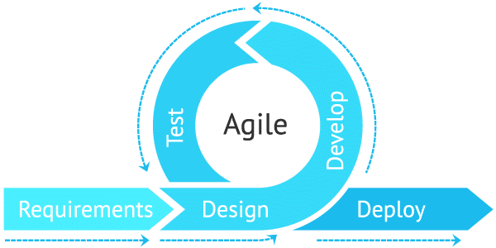

Figure 1: agile methodology

## 1.10. Testing Methodology

The testing methodology for the "Online Employee Employer Interconnection Website" project involves a systematic approach to ensure the functionality, performance, and usability of the platform. The testing process will include the following steps:

**1. Requirements Analysis:** Review and analyze the requirements specified in the SRS (Software Requirements Specification) document to gain a clear understanding of the expected functionality of the online platform.

**2. Test Planning:** Develop a comprehensive test plan that outlines the objectives, scope, test scenarios, and test cases to be executed during the testing phase. Define the roles and responsibilities of the testing team members.

**3. Test Case Design:** Design test cases based on the identified functional requirements and user scenarios. Test cases should cover all critical functionalities of the platform, including user registration, job search, job application submission, employer posting, and communication features.

**4. Test Environment Setup:** Set up the necessary testing environment, including the required hardware, software, and database configurations, to ensure a realistic simulation of the platform's usage.

**5. Test Execution:** Execute the prepared test cases systematically, following the predefined test plan. Document the test results, including any observed defects or issues.

**6. Functional Testing:** Conduct functional testing to validate that all functional requirements specified in the SRS document are properly implemented and functioning as expected. Test various scenarios, such as user registration, login/logout processes, search filters, and application submission.

**7. Performance Testing:** Evaluate the performance and responsiveness of the platform under different loads and conditions. Measure factors such as the platform's response time, scalability, and resource usage to ensure it can handle the expected user traffic efficiently.

**8. Usability Testing:** Assess the user-friendliness and ease of navigation of the platform. Conduct user testing sessions to gather feedback on the user interface, layout, and intuitiveness of the platform, ensuring a positive user experience.

**9. Security Testing:** Perform security testing to identify vulnerabilities and ensure the platform's data protection measures, such as secure user login, encryption of sensitive information, and prevention of unauthorized access, are in place.

**10. Regression Testing:** Execute a regression testing cycle to ensure that any fixes or enhancements made during the testing process do not impact existing functionalities or introduce new issues.

**11. Defect Tracking and Reporting:** Use a defect tracking system to log and monitor any identified defects. Generate comprehensive test reports, including the summary of test results, detected defects, and recommendations for improvement.

**12. Test Completion and Sign-off:** Once all test cases have been executed and all identified defects have been addressed, obtain approval and sign-off from relevant stakeholders, confirming the completion of the testing phase.

By following this testing methodology, the "Online Employee Employer Interconnection Website" project aims to uncover any issues or limitations in the platform, ensuring a reliable, efficient, and user-friendly system that can successfully overcome the challenges of the manual and face-to-face employment process.

## 1.11. Beneficiaries Of The Project

The beneficiaries of the research proposal on developing an Online Employee-Employer Interconnection Website to overcome manual and face-to-face employment processes are:

**Job Seekers:** The online platform will provide job seekers with a user-friendly and convenient way to search for job opportunities. They can create personalized profiles showcasing their skills, qualifications, and experiences to improve their visibility to potential employers. The platform will save them time and effort by eliminating the need for traditional paper-based applications and allowing them to connect directly with employers.

**Employers**: The online platform will simplify the hiring process for employers by providing them with a centralized platform to post job vacancies, review candidate profiles, and communicate directly with potential employees. This will increase the efficiency of their recruitment process, save time and resources, and enable them to reach a larger pool of qualified candidates without geographical constraints.

**Small and Medium-sized Enterprises (SMEs):** SMEs often face challenges in accessing skilled manpower due to limited resources and lack of visibility compared to larger corporations. The proposed online platform will level the playing field by providing SMEs with an equal opportunity to access a wide range of potential employees and compete for talent on a more transparent and merit-based platform.

**Employment Agencies:** Employment agencies responsible for recruiting and hiring will benefit from the enhanced efficiency and effectiveness offered by the online platform. They will have access to a streamlined system that automates several steps of the recruitment process, such as resume screening and initial candidate evaluation, allowing them to focus on more strategic aspects of talent acquisition.

**Economic Growth:** By facilitating a more efficient labor market, the proposed online platform will contribute to overall economic growth. Improved job matching and reduced time-to-hire will lead to increased productivity and improved job satisfaction among employees. Furthermore, by connecting job seekers with suitable opportunities, the platform can help reduce unemployment rates and provide opportunities for economic mobility.

**Society as a Whole:** The adoption of an Online Employee-Employer Interconnection Website will help foster a more inclusive and transparent job market. It will empower individuals from diverse backgrounds to access job opportunities and contribute to their communities. Furthermore, by reducing the reliance on manual processes, the platform will contribute to environmental sustainability by saving paper and reducing carbon emissions associated with in-person interviews and commuting.

Overall, the proposed research aims to benefit various stakeholders in the employment ecosystem by enhancing convenience, efficiency, and transparency in job search and recruitment processes.

## 1.12. Feasibility Study

The feasibility study of the proposed project, the development of an online employee-employer interconnection website, aims to assess the practicality and viability of implementing the system. This study examines various aspects, including technical, economic, operational, and schedule feasibility, to determine whether the project is achievable within the allocated resources and time frame.

**Technical Feasibility**

The technical feasibility assessment focuses on evaluating the availability of the required technology, skills, and infrastructure to develop and maintain the online employee-employer interconnection website. This involves analyzing factors such as the availability of suitable development platforms, expertise in web development, hosting capabilities, and compatibility with existing systems. The study will also consider any potential technical challenges, such as integrating with third-party systems or ensuring robust data security measures.

**Economic Feasibility**

The economic feasibility analysis assesses the financial viability of implementing the project. This involves estimating the costs associated with development, hosting, maintenance, and operation of the online platform. The study will consider factors such as development costs, licensing fees, hosting expenses, marketing and promotion expenditures, and ongoing maintenance costs. The analysis will also involve evaluating potential revenue streams, such as subscription fees, advertising, or partnerships, to determine the financial sustainability of the project.

**Operational Feasibility**

The operational feasibility assessment examines the practicality of implementing and managing the online employee-employer interconnection website. This involves considering factors such as the availability of skilled personnel to maintain and support the platform, the ease of use for both employers and job seekers, and any training or support needs. The study will also analyze potential risks and challenges related to user adoption, data management, and scalability to ensure the smooth operation of the platform.

**Schedule Feasibility**

The schedule feasibility analysis evaluates the project timeline and whether it can be completed within the desired timeframe. This involves considering factors such as the availability of resources, the complexity of development, and potential dependencies on external factors (such as regulatory approvals or integration with other systems). The study will also identify any critical path activities and potential risks that may impact the project timeline.

Based on the feasibility study, the project team will be able to determine whether the development and implementation of the online employee-employer interconnection website are practical and achievable. Any identified challenges or risks will be addressed, and appropriate mitigation strategies will be put in place to ensure a successful and viable project implementation.

## 1.13. Time Schedule

This involves questions such as how much time is available to build the new system, when it can be built. The plan explains the tasks verses the time (in weeks) they will take to complete.

Table 1 : project time schedule

|  |  |  |  |  |  |  |  |
| --- | --- | --- | --- | --- | --- | --- | --- |
| Tasks | January | February | March | April | may | Jun | Task assigned to |
| Requirement  gathering |  |  |  |  |  |  | Hirut T. |
| Analysis |  |  |  |  |  |  | G/tsadik B. |
| Design |  |  |  |  |  |  | Guesh G. |
| Coding |  |  |  |  |  |  | Haftay D. |
| Testing |  |  |  |  |  |  | Hayat T. |
| Implement |  |  |  |  |  |  | Lidya |
| presentation | 1 |  |  |  |  |  | All me |

## 1.14. Budget

To complete our project starting down from the beginning up to the end of this project we planned the following cost list.

Table 2: Hardware budget plan

|  |  |  |  |  |  |  |
| --- | --- | --- | --- | --- | --- | --- |
| NO. | Materials | Quantity | Unit | Birr | Cent | Birr total |
| 1 | Paper | 1 | Packet | 750 | 00 | 750.00 ETB |
| 2 | Pen | 5 | PCS | 15 | 00 | 125.00 ETB |
| 3 | Flash Disk | 1 | Single | 400 | 00 | 400.00 ETB |
| 4 | Mobile Card | 10 | Single | 25 | 00 | 250.00 ETB |
| 5 | Printing | 70 | Single | 5 | 00 | 350.00 ETB |
| 6 | Binding | 3 | Single | 30 | 00 | 90.00 ETB |
| TOTAL | | | | | | 1965.00TB |

# CHAPTER TWO

## REQUIREMENT ANALYSIS DESCRIPTION

## 2.1. Overview Of The Existing System

The existing system of the employment process is primarily manual and relies on face-to-face interactions between job seekers and employers. Job seekers typically search for employment opportunities through newspaper advertisements, physical job boards, or personal networks. They then submit physical copies of their resumes and other required documents to potential employers. Employers, on the other hand, manually process these physical applications, screen candidates, and conduct face-to-face interviews. This manual and face-to-face system is time-consuming, inefficient, and limited in its reach.

### 2.1.1. Problems In The Existing System

The existing system of manual and face-to-face employment processes presents several challenges and limitations, including:

**A) Time and Cost Inefficiency:** Job seekers have to invest significant time and effort in searching for job opportunities, physically submitting applications and attending interviews. Employers also face challenges in managing and processing physical copies of applications and conducting multiple face-to-face interviews. These processes can be costly and time-consuming for both parties.

**B) Limited Geographic Reach:** The existing system restricts job seekers to local employment opportunities, often missing out on opportunities in other regions or countries. Similarly, employers may not be able to access a diverse pool of talent from different geographic locations.

**C) Lack of Comprehensive Information**: Job seekers may struggle to access comprehensive and up-to-date information about job opportunities, industry trends, or employer requirements. This lack of information hinders job seekers in making informed decisions and effectively presenting themselves as suitable candidates. Likewise, employers may find it challenging to attract qualified candidates efficiently.

**D) Communication Barriers:** The existing system relies on physical interaction, making it difficult for job seekers and employers to communicate efficiently, especially when they are geographically dispersed. It can result in miscommunications, delayed responses, and difficulties in organizing interviews or providing updates on application status.

**E) Limited Accessibility for Small and Medium Enterprises (SMEs):** SMEs often face challenges in attracting qualified candidates due to limited resources, lack of brand recognition, or geographical constraints. The existing system makes it harder for SMEs to compete with larger organizations in reaching potential candidates effectively.

The problems inherent in the existing manual and face-to-face employment system necessitate the development of an innovative and efficient online platform, as proposed in the "Online Employee and Employer Interconnection" SRS document. This platform aims to address these challenges and create a more streamlined and effective employment process.

### 2.1.2. Activities Of The Existing System

The existing system, which follows a manual and face-to-face employment process, involves several activities, including:

**A) Job Searching:** Job-seekers manually search for job opportunities through various channels such as newspapers, job boards, or personal referrals.

**B) Resume Preparation:** Job-seekers create their resumes manually, either in hardcopy or digital format, highlighting their skills, qualifications, and work experience.

**C) Application Submission:** Job-seekers physically submit their resumes and application documents to potential employers through mail, in-person visits, or email attachments.

**D) Application Review and Shortlisting:** Employers manually review and assess each received application, shortlisting candidates based on their qualifications, skills, and experience.

**E) Interview Process:** Employers schedule face-to-face interviews with shortlisted candidates and conduct in-person interviews to assess their suitability for the job.

**F) Communication and Feedback**: Employers provide updates, interview feedback, and job offers to candidates either in-person, via phone calls, or email.

**G) Result Communication:** After the interview process, employers manually inform successful candidates about the job offer, and unsuccessful candidates may receive no response or a rejection letter.

**H) Administrative Processes:** Employers track and manage applications, resumes, and interview records manually, potentially leading to errors or delays in the process.

### 2.1.3. Business Rules

Business Rules of the "Online Employee Employer Interconnection Website" Project:

**A) Job-seeker Registration:** Job-seekers must register on the platform and create an online profile, providing accurate and up-to-date information about their skills, qualifications, and work experience.

**B) Job Postings:** Employers can post available job positions, including the job description, required qualifications, and any additional details.

**C) Job Searching and Application:** Job-seekers can search for jobs based on their preferences and apply for positions electronically by submitting their online resumes or application forms.

**D) See Result (Response):** Employers and employees will receive notifications or feedback about their desired workers and jobs when they login to the system.

**E) Data Privacy and Security:** The platform ensures the confidentiality and security of user data, adhering to relevant data protection regulations.

By implementing these business rules in the "Online Employee Employer Interconnection Website," the project aims to streamline the employment process, eliminate the need for manual paperwork and face-to-face interactions, and leverage technology to overcome the limitations of the existing manual and face-to-face employment process.

## 2.2. Over View Of The Proposed System Design And Architecture

The proposed system design and architecture of the "Online Employee and Employer Interconnection" website research proposal aims to create an efficient and user-friendly platform that overcomes the limitations of manual and face-to-face employment processes. The system will consist of the following components:

**1. User Interface:** The user interface will be designed to provide a seamless and intuitive experience for both job seekers and employers. It will include features such as a search bar, filters, and clear navigation menus to facilitate easy access to job listings, profile management.

**2. Database:** The system will incorporate a robust database to store and manage user information, job listings, resumes, messages, and other relevant data. The database will ensure secure data storage and retrieval, allowing quick access to relevant information when needed.

**3. User Registration and Authentication:** The system will include a user registration module that allows job seekers and employers to create accounts. Authentication mechanisms will be implemented to verify user credentials and ensure secure access to the platform.

**4. Job Search and Filtering:** The system will provide a comprehensive job search feature, allowing job seekers to browse and filter job listings based on their preferences. Filters may include location, industry, job type, and experience level, enabling users to find suitable employment opportunities efficiently.

**5. Job Posting and Management:** The system will offer employers the ability to create, manage, and update job postings. Employers can provide detailed descriptions, requirements, and application instructions for interested job seekers. The system will ensure that job postings are visible to the relevant audience and easily searchable.

**6. Resume upload and Profile Management**: Job seekers will have the option to upload their resumes and other supporting documents to their profiles. The system will allow job seekers to update and manage their profiles, ensuring that employers have access to the most up-to-date information.

**9. Admin Panel:** The system will include an admin panel that allows administrators to manage and monitor the overall operation of the website. This will include user management, job listing moderation, analytics, and system maintenance tasks.

**10. Security and Privacy Measures:** The system will implement necessary security measures, including secure user authentication during login process, and access control, to ensure the privacy and protection of user data.

Overall, the proposed system design and architecture of the "Online Employee and Employer Interconnection" website research proposal aims to deliver a user-centric platform that facilitates efficient job search, communication, and hiring processes. It leverages modern technologies to streamline the employment process and help bridge the gap between job seekers and employers in a digital environment.

### 2.2.1. Functional Requirements

Define the specific functionalities of the system from the user's perspective, focusing on:

**Employer:**

The system should allow the Employer to register, post his job vacancies with detail information.

The system should allow the Employer to log in to the system using his username and password,

The system should allow the Employer to update his profile, see results about his required worked after logged in to the system.

**Employee (job seeker):**

The system should allow the Employee to register, with the detailed required information.

The system should allow the Employee to attach his certificate of skill if required.

The system should allow the Employee to login to the system using his username and password.

The system should allow the Employee to see job lists and apply to desired job.

The system should allow the Employee to see his statues (response) on the system after logged in.

**ADMIN:**

The system should allow the Admin to login to the system using his username and password and admin role.

The system should allow the admin to see list of registered jobseekers, employers and list of job vacancies.

The system should allow the admin to assign employers and employee based on their requirements and registered descriptions.

The system should allow the admin to fill the agreement form of employee and employers.

The system should allow the admin to upload the guarantees (employee’s relative) id card to the system.

The System should allow admin to manage and monitor the overall operation of the website.

### 2.2.2. Non-Functional Requirements

Define the overall quality attributes of the system, including:

Performance: Response time, system uptime, scalability, load handling capacity.

Security: Data encryption, authentication, authorization, access control, data privacy.

Usability: User interface design, ease of use, learnability, accessibility.

**Reliability:** System availability, error handling, fault tolerance, recovery mechanisms.

**Maintainability:** Ease of modifications, updates, debugging, code documentation.

**Compatibility**: Cross-browser compatibility, device compatibility, language support.

Define measurable metrics or benchmarks for each non-functional requirement to ensure they are met during development and testing.

### 2.2.3. Assumptions

A) The target user base possesses basic computer literacy and has access to the internet.

B) Users will provide accurate and authentic information when creating their profiles and applying for job positions.

C) The platform will be compatible with common web browsers and operating systems.

D) Sufficient resources, including hardware and server capacity, will be available to support the expected user traffic and data storage requirements.

E) Users' personal data will be handled securely and in compliance with relevant data protection regulations.

### 2.2.4. Constraints

**A) Time Constraint:** The development and implementation of the Online Employee-Employer Interconnection Website will be subject to a specific timeline, which may impact the depth and breadth of features that can be included in the initial release.

**B) Budget Constraint:** The project will operate within a pre-defined budget, which may limit the extent of technological infrastructure and marketing efforts.

**C) Technical Constraint:** The platform must be designed to be accessible and usable across different devices, screen sizes, and internet connection speeds while ensuring optimal performance and user experience.

**B) Security and Privacy Constraints**: The system must comply with relevant security standards and implement measures to protect user data, prevent unauthorized access, and ensure secure communication between users.

**E) Legal and Regulatory Constraints**: The development and operation of the platform must comply with all applicable laws and regulations related to employment, data protection, and online services.

**F) User Acceptance:** The success of the platform depends on user adoption and engagement. Encouraging users to trust and actively use the platform may require effective marketing and user support strategies.

It is important to note that these assumptions and constraints are provided as an example and may vary depending on the specific context and requirements of the proposed Online Employee-Employer Interconnection Website project.

### 2.2.5. System Tool Requirement (Software And Hardware)

The hardware tools required are:

Table 3: hardware tools requirement

|  |  |
| --- | --- |
| Hardware component | Minimum requirement |
| Computer or laptop |  |
| Processor Type (system type) | 64 bit/32bit operating system |
| Memory (RAM) | 2GB and above |
| Processor Speed | 3.20 GHZ and above |
| Hard Disk Space | 10GB and above |
| Mouse | Any pointing device |
| Key board | Keys |

**The software tools:**

While developing the project starts from the documentation to the implementation, we use the following case tools:

Table 4: system development tools

|  |  |
| --- | --- |
| Tools | Activities |
| Notepad, Sublime text, Visual studio code | For coding PHP web language |
| CSS | For making attractive layout |
| PHP | Back end (Server-side coding) |
| HTML | Client-side coding |
| MYSQL | Back end (data base) |
| WAMP, XAMP Server | For storing patient information permanently |
| Mozilla Firefox, IE, Google Chrome, Opera | Browsers |
| MS office word 2016 | For Documentation |
| MS office PowerPoint 2016 | For Presentation |
| Adobe Photo Shop CS6 | To design back ground images |

Table 5: Software Budget Plan

|  |  |  |  |
| --- | --- | --- | --- |
| Tools | Activities | access | cost |
| Notepad, Sublime text, Visual studio code | For coding PHP web language | internet | free |
| CSS | For making attractive layout | internet | free |
| PHP | Back end (Server-side coding) | internet | free |
| HTML | Client-side coding | internet | free |
| MYSQL | Back end (data base) | internet | free |
| WAMP, XAMP Server | For storing patient information permanently | internet | free |
| Mozilla Firefox, IE, Google Chrome, Opera | Browsers | internet | free |
| MS office word 2016 | For Documentation | internet | free |
| MS office PowerPoint 2016 | For Presentation | internet | free |
| Edraw Max7.9 and Visio 2010 | To draw UML Diagram and for designs | internet | free |
| Adobe Photo Shop CS6 | To design back ground images | internet | free |

# CHAPETER THREE

# SYSTEM MODELING

3.1. Introduction

System modeling refers to the process of defining and representing a system's structure, behavior, and interactions. In the context of the "Online Employee Employer Interconnection Web Site" project, system modeling helps in visualizing and understanding the proposed system's various components and their relationships. It provides a high-level overview of the system's architecture and functionality.

## 3.2. Use Case Model

A use case model identifies different scenarios (use cases) where users interact with the system. Each use case captures the goals, actors involved, and steps taken to achieve those goals. This model helps visualize the system's functionalities from different user perspectives.

### 3.2.1. Actor Identification

This proposed system has three (3) actors: an employer, employee (job seeker) and Admin (the broker in the Existing system). And these actors have the following functionalities in the proposed system.

**Actors:**

**Employer:** Represents an individual or organization seeking to hire employees. Key functionalities include:

Registering with his detailed information (creating user account).

Login to the system using his user name password and role.

Posting job listing with detailed descriptions, requirements, and benefits.

See his response about the job he posted.

Managing (update) posted jobs and applications.

**Employee:** Represents an individual seeking employment opportunities. Key functionalities include:

Registering with his detailed information (creating user account).

Login to the system using his user name password and role.

Creating a profile high lighting skills, experience, and educational background.

Searching for jobs (see list of job posts).

Managing (update) his profiles in the system.

See his response (result) about the job he applied.

**System Administrator:** Manages the overall platform and ensures its smooth operation. Key functionalities include:

Login to the system using his user name password and role.

Searching for jobs (see list of job posts).

See list of employees and employers.

Assign employee to employer (interconnection).

Fill employee-employer agreement form and print it to give for both.

Upload the Guarantee (employee’s relative) ID card.

Monitoring system performance and security.

Maintaining system integrity and resolving technical issues.

### 3.2.2. Use Case Diagram

A use case diagram is a visual depiction of use cases and actors involved. It shows how actors interact with the system to achieve their goals.

This is use case diagram of our project title called “On-line Employee-Employer Interconnection website” that aims to overcome the limitations of manual and face to face recruitment (employee-employer interconnection) process.

This diagram provides a clear understanding of the overall system functionality.

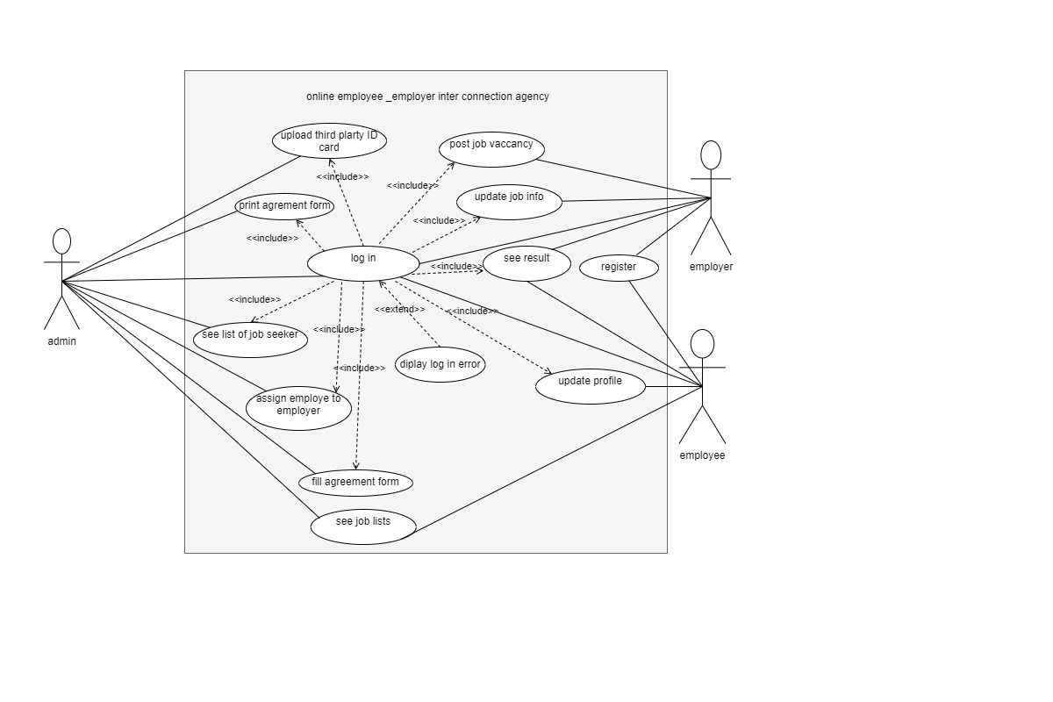

Figure 2: use case diagram

### 3.2.3. Description Of Use Case

Each use case is further elaborated with a detailed description. This description includes:

**Goals:** What the user wants to achieve through the use case.

**Preconditions:** Conditions that must be met before starting the use case.

**Steps:** The sequence of steps involved in the interaction.

**Post conditions:** The outcome of the use case and any post-interaction conditions.

**Alternative Flows:** Any potential variations or exceptions in the interaction flow.

The following tables are using case descriptions about each use cases in our project.

Table 6: use case description for registration

|  |  |  |
| --- | --- | --- |
| Use case number | UC-1 | |
| USE CASE NAME | **RAGISTRATION** | |
| Use case description | To Register Employee and Employer to using the system. | |
| ACTOR | Employee, Employer | |
| Pre-condition |  | |
| Flow of events for main success scenarios | **User** **action** | **System** **response** |
| 1. The user opens the browser.  2. Type URL on address bar.  4. The user Clicks register link.  6. User fills basic information and then clicks submit button. | 3. The system provides an interface with home page.  5. System provides registration form.  7. System validates for inputs.  8. If valid input the system save to database with success message. |
| Flow of events for alternative scenarios | 4. The system allows to the user to click correct link or to search again.  7. A. If incorrect input occurred system displays error message. | |
| Post condition | The Employee and employer will register successfully. | |

Table 7: use case description for login use case

|  |  |  |
| --- | --- | --- |
| Use case number | UC-2 | |
| USE CASE NAME | **LOG IN** | |
| Use case description | To sign in users to the system. | |
| ACTOR | ADMIN, EMPLOYEE, EMPLOYER | |
| Pre-condition | The Employee employer and admin should be registered. | |
| Flow of events for main success scenarios | **User** **action** | **System** **response** |
| 1. The user opens the browser.  2. Type URL on address bar.  4. The user Clicks Login link.  6. User fills username, password and his role and then clicks LOGIN button. | 3. The system provides an interface with home page.  5. System provides login form.  7. System validates for inputs.  8. If valid input the system redirects user to his pages. |
| Flow of events for alternative scenarios | 7. A, the system displays error message and returns to step 6 if an error occurred. | |
| Post condition | The user will sign in to the system. | |

Table 8: use case description for Job post

|  |  |  |
| --- | --- | --- |
| Use case number | UC-3 | |
| **USE CASE NAME** | **JOB POST** | |
| Use case description | To post an Employer a job vacancy to the system. | |
| ACTOR | Employer | |
| Pre-condition | An employer must login to the system First. | |
| Flow of events for main success scenarios | **User** **Action** | **System** **Response** |
| 1. The Employer clicks the Post job link  3. User fills All Required fields and descriptions about his job and Clicks submit button to save the job to Database. | 2. System provides job post form.  4. system validates all Filled fields.  8. If valid input the system save the job description to database with success message. |
| Flow of events for alternative scenarios | 4. If incorrect input occurred system displays error message and allow the employer to fill again correctly. | |
| Post condition | The employer will post his job vacancy successfully. | |

Table 9: use case description for See job list and search job

|  |  |  |
| --- | --- | --- |
| Use case number | UC-4 | |
| **USE CASE NAME** | **SEE JOB LIST AND SEARCH JOB** | |
| Use case description | To see and search list of job vacancies in the system. | |
| ACTOR | Employee, Admin or any other | |
| Pre-condition |  | |
| Flow of events for main success scenarios | **User** **action** | **System** **response** |
| 1. The User opens the browser.  2. Type URL on address bar.  4. The user Clicks job list link or Search a job.  6.User clicks close button to close the page after reads the job posts. | 3. The system provides an interface with home page.  5. System displays list of posted job vacancies or related to search keyword with detail job description.  7. System closes the page and redirect to home page. |
| Flow of events for alternative scenarios | 4.a, the system displays no related to your search message if no result found, | |
| Post condition |  | |

Table 10: use case description for see list of employee and employer

|  |  |  |
| --- | --- | --- |
| Use case number | UC-5 | |
| USE CASE NAME | **SEE LIST OF EMPLOYEE AND EMPLOYER** | |
| Use case description | To see list of registered employees and employers in the system. | |
| ACTOR | ADMIN | |
| Pre-condition | The admin should logged in first | |
| Flow of events for main success scenarios | **User** **action** | **System** **response** |
| 1. The Admin Clicks List of employer link or List of Employee link.  3. Admin clicks close button to close the page after reads the employee and employer lists. | 2. System displays list of registered Employers and Employees.  4. System closes the page and redirect to admin page. |
| Flow of events for alternative scenarios | 4.a, the system displays no registered employees or employer if no result found, | |
| Post condition |  | |

Table 11:use case description for assign employee-employer

|  |  |  |
| --- | --- | --- |
| Use case number | UC-6 | |
| USE CASE NAME | **ASSIGN EMPLOYEE-EMPLOYER** | |
| Use case description | To Assign(Interconnect) employee and employer based based on their requirements. | |
| ACTOR | ADMIN | |
| Pre-condition | The admin must logged in first. | |
| Flow of events for main success scenarios | **User** **action** | **System** **response** |
| 1. The user Clicks assign job link.  3. The admin fills the table or assigns job seeker based on their required qualifications with employers by matching with their requirements. Finally clicks Submit button to save to data base table. | 2. System displays Job assign table.  4. System saves the filled table to DB. And displays successful message. then closes the page and redirect to admin page. |
| Flow of events for alternative scenarios | 4. A, the system displays error message if any error found. | |
| Post condition | Employee and employer will connect. And they can see their response by logging in to the system. | |

Table 12: use case description for see response

|  |  |  |
| --- | --- | --- |
| Use case number | UC-7 | |
| USE CASE NAME | **SEE RESPONSE** | |
| Use case description | To see an employee and employer their result (response) in the system. | |
| ACTOR | Employee, Employer | |
| Pre-condition | An Employee and employer must log in first to the system. | |
| Flow of events for main success scenarios | **User** **action** | **System** **response** |
| 1. The Employee or employer Clicks SEE RESPONSE link.  3. User clicks close button to close the page after see their response. | 2. System displays list their details with assigned or waiting response and other information.  4. System closes the page and redirect to their page. |
| Flow of events for alternative scenarios | 4. the system displays no related to your search message if no result found. | |
| Post condition | They must log out by clicking the logout button. | |

Table 13: use case description for fill agreement form and print it.

|  |  |  |
| --- | --- | --- |
| Use case number | UC-8 | |
| USE CASE NAME | **FILL AGREEMENT AND PRINT IT** | |
| Use case description | To Fill the agreement form of employee and employer in the system to save it in data base and print the agreement paper to give for both employee and employer. | |
| ACTOR | Admin | |
| Pre-condition | The admin must logged in first to the system | |
| Flow of events for main success scenarios | **User** **action** | **System** **response** |
| 1. The user Clicks Fill agreement link.  3. The admin fills the form and uploads the employee-guarantee’s ID Card and then Save it to data base by clicking the save button.  5. Admin clicks the print button to print the form.  7. User clicks close button to close the page after he finishes his work. | 2. System displays the page that contains the Agreement form.  4. System saves the form to data base.  6. System prints the agreement form.  8. System closes the page and redirect to his page. |
| Flow of events for alternative scenarios | 4.a, the system displays error message if any error occurred. | |
| Post condition |  | |

Table 14: use case description for update

|  |  |  |
| --- | --- | --- |
| Use case number | UC-9 | |
| USE CASE NAME | **UPDATE PRIFILE** | |
| Use case description | To update their profile both employee and employer. | |
| ACTOR | Employee, Employer | |
| Pre-condition | They must login first to the system. | |
| Flow of events for main success scenarios | **User** **action** | **System** **response** |
| 1. The user Clicks Update button in their page.  3. User Updates the field require to update and clicks the Save button.  5. User clicks close button to close the page after reads the job posts. | 2. System displays their detail information and allows modifying it.  4. System validates the input and if no error saves it to database.  7. System closes the page and redirect to home page. |
| Flow of events for alternative scenarios | 4.a, the system displays error message if any error found, | |
| Post condition | User must logout by clicking the logout button. | |

Table 15: use case description for log out use case

|  |  |  |
| --- | --- | --- |
| Use case number | UC-10 | |
| USE CASE NAME | **LOG OUT** | |
| Use case description | To Logout users from the system. | |
| ACTOR | ADMIN, EMPLOYEE, EMPLOYER | |
| Pre-condition | The Employee employer and admin should be logged in first. | |
| Flow of events for main success scenarios | **User** **action** | **System** **response** |
| 1. The Admin, Employee and Employer after Completion of their task in the system they clicks the Logout button. | 3. The System redirects the user to home page. |

### 3.2.4. Class Diagram

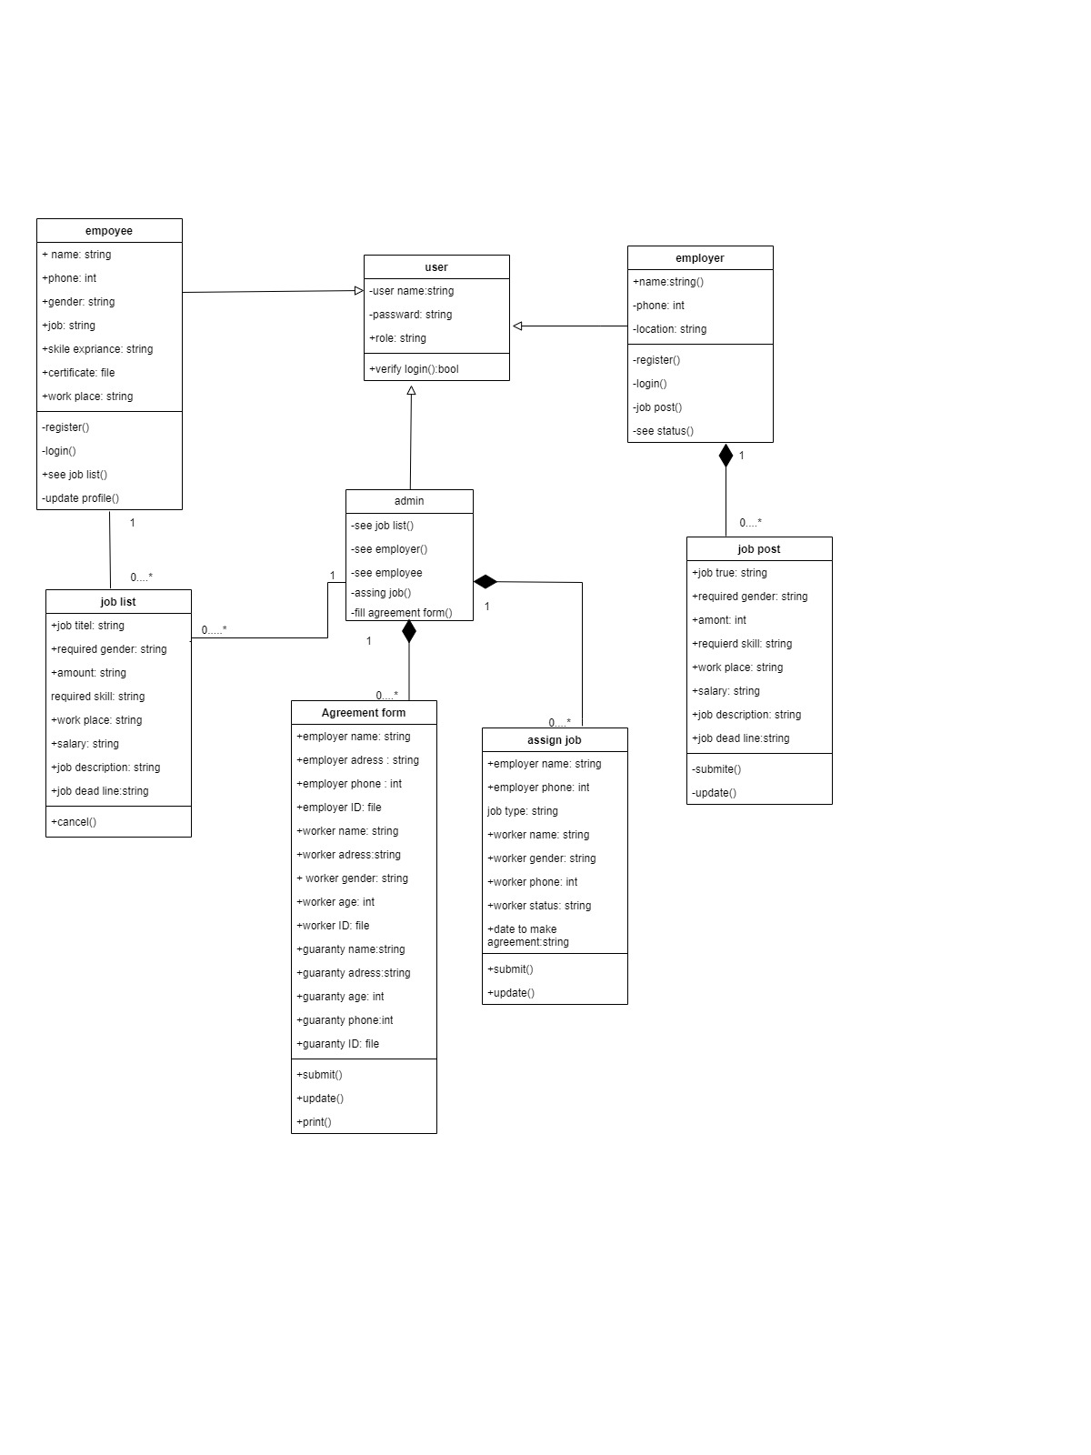

Figure 3 : class diagram

### 3.2.5. Sequence Diagram

A sequence diagram shows the specific sequence of interactions between objects within the system during a particular use case. It helps visualize the message flow and timing between objects, providing a deeper understanding of the system's internal workings.

The following diagrams are sequence diagrams of our proposed system.

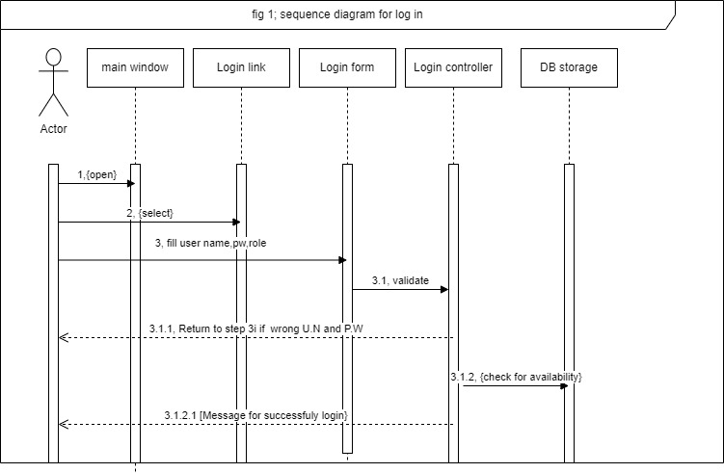

Figure 4: sequence diagram for login

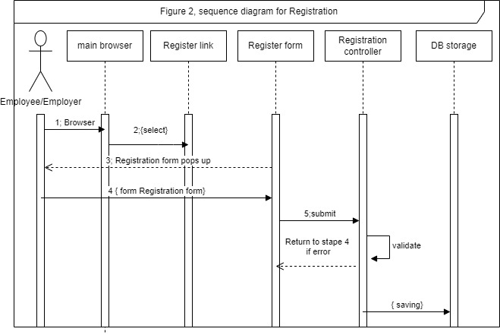

Figure 5: sequence diagram for registration

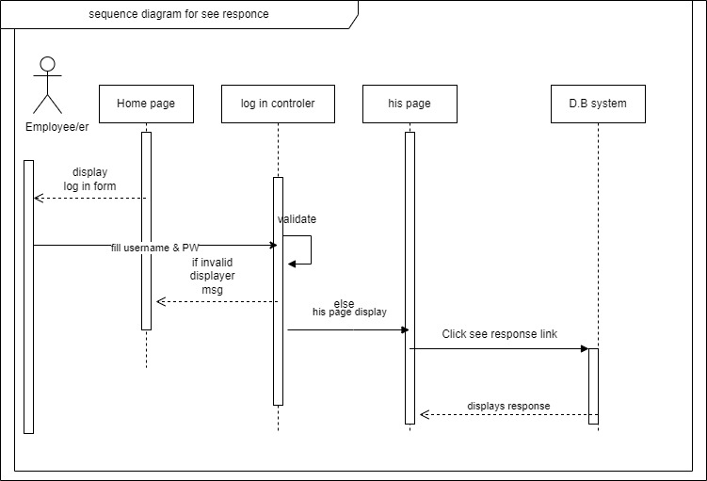

Figure 6: sequence diagram for see response

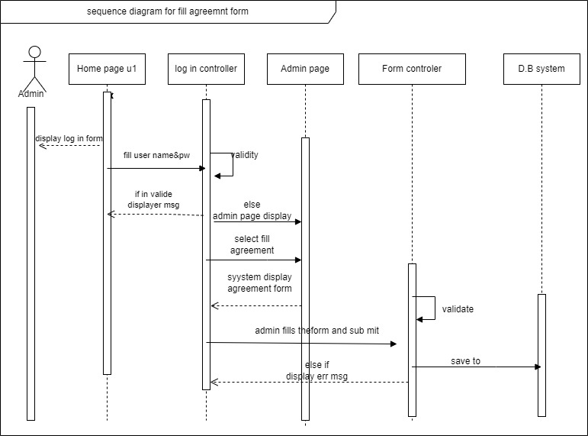

Figure 7: sequence diagram for fill agreement form

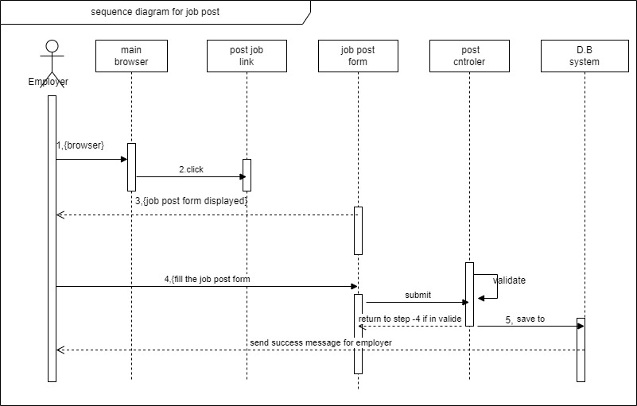

Figure 8: sequence diagram for job post

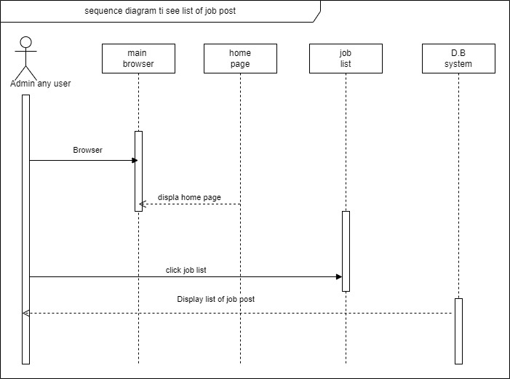

Figure 9: sequence diagram to see list of the job

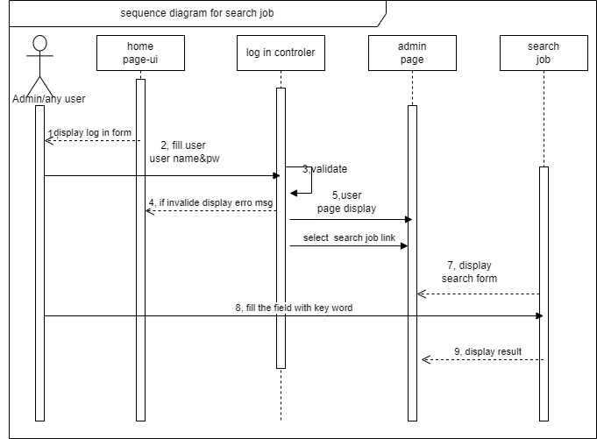

Figure 10: sequence diagram for search job

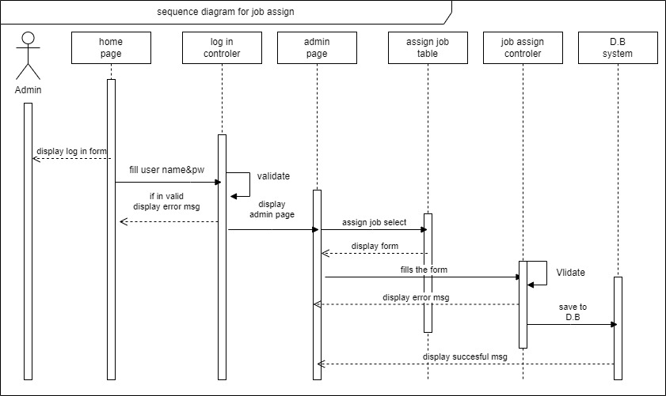

Figure 11: sequence diagram for job assign

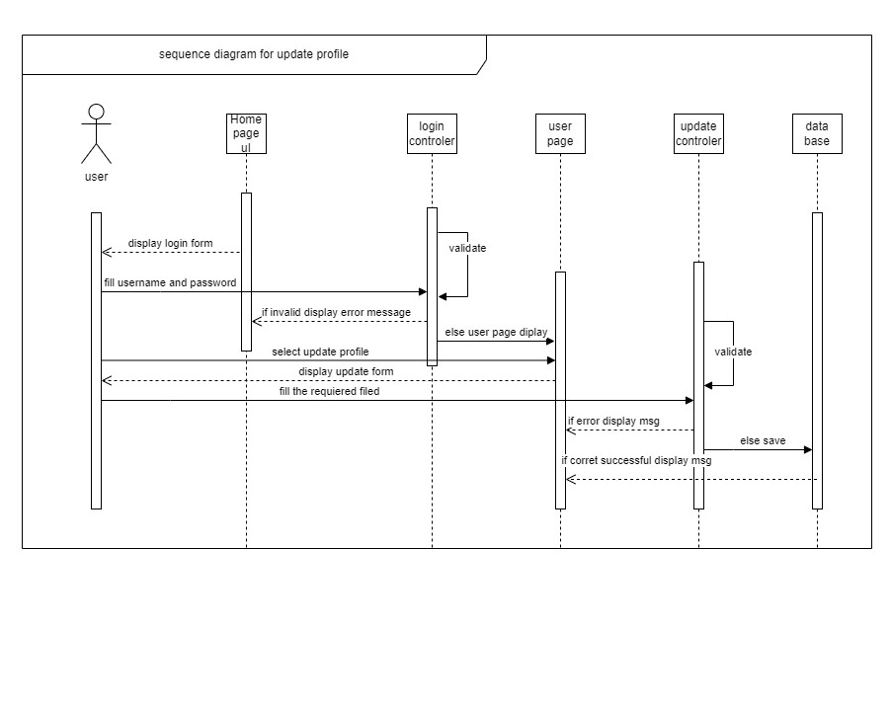

Figure 12: sequence diagram for update profile

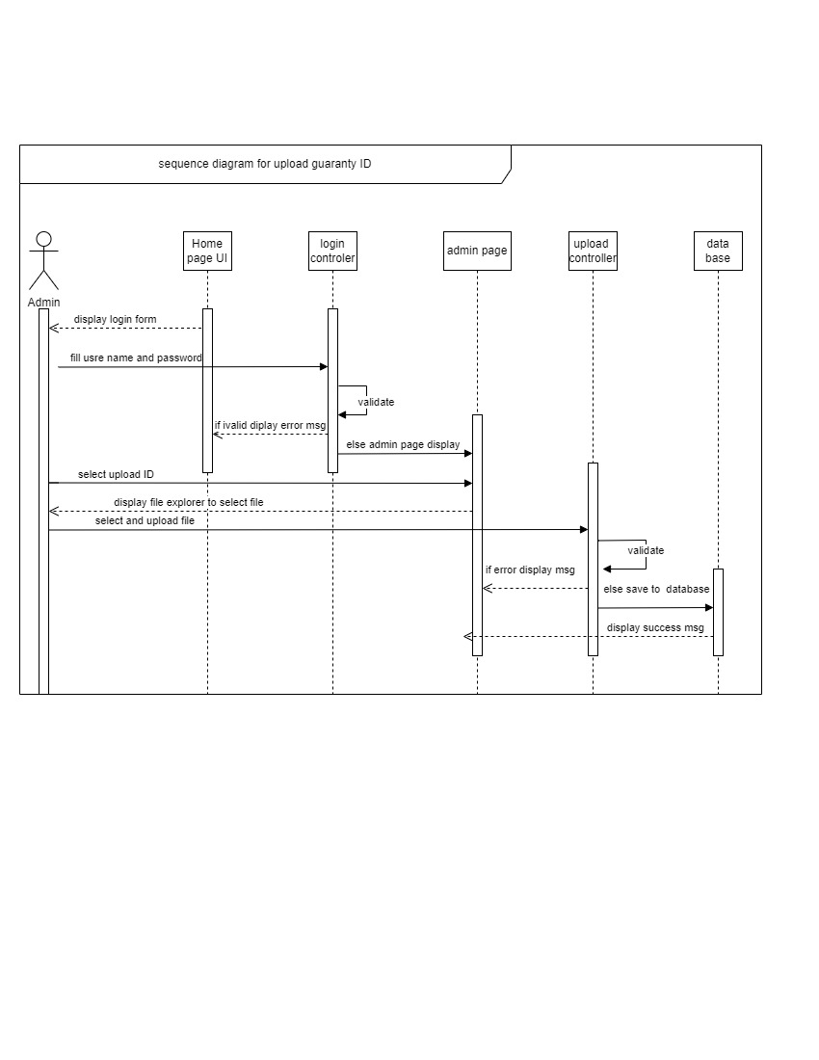

Figure 13: sequence diagram for upload guaranty id

# References:

Here List all references used in the SRS proposal, including research papers, articles, books, websites, and other sources of information.

A THESIS SUBMITTED IN PARTIAL FULFILLMENT OF THE REQUIREMENTS FOR THE BACHELOR OF EDUCATION (BED) IN INFORMATION TECHNOLOGY TOPIC: DESIGN AND IMPLEMENTATION OF ONLINE JOB PORTAL

Chat Gpt AI, Bing AI, Bard AI

* [**https://www.perforce.com/blog/alm/how-write-software-requirements-specification-srs-document**](https://www.perforce.com/blog/alm/how-write-software-requirements-specification-srs-document)
* [**https://www.geeksforgeeks.org/software-requirement-specification-srs-format/**](https://www.geeksforgeeks.org/software-requirement-specification-srs-format/)
* [**https://slcc.pressbooks.pub/technicalwritingatslcc/chapter/software-requirements-specification-srs/**](https://slcc.pressbooks.pub/technicalwritingatslcc/chapter/software-requirements-specification-srs/)

# Annex

Here list of figures that describe the manual and face to face employee and employer interconnection system we found during requirement gathering by interview.

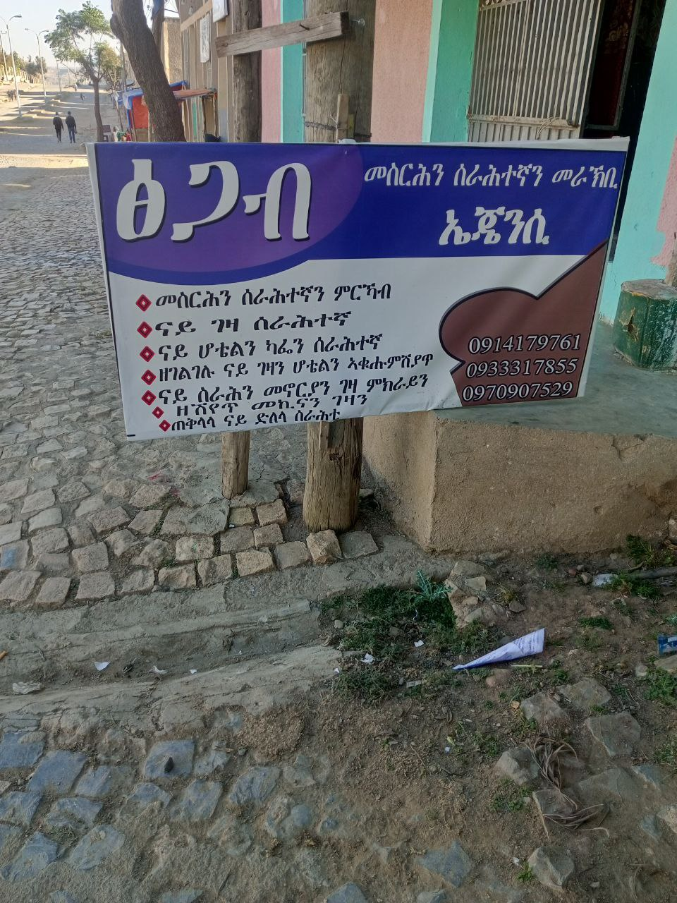

Figure 14: The existing systems agency advertisement method

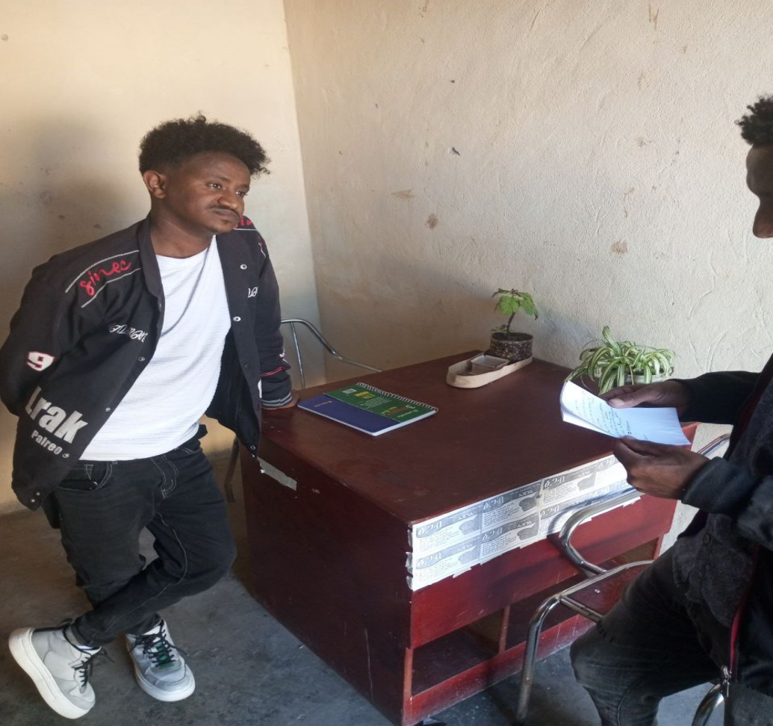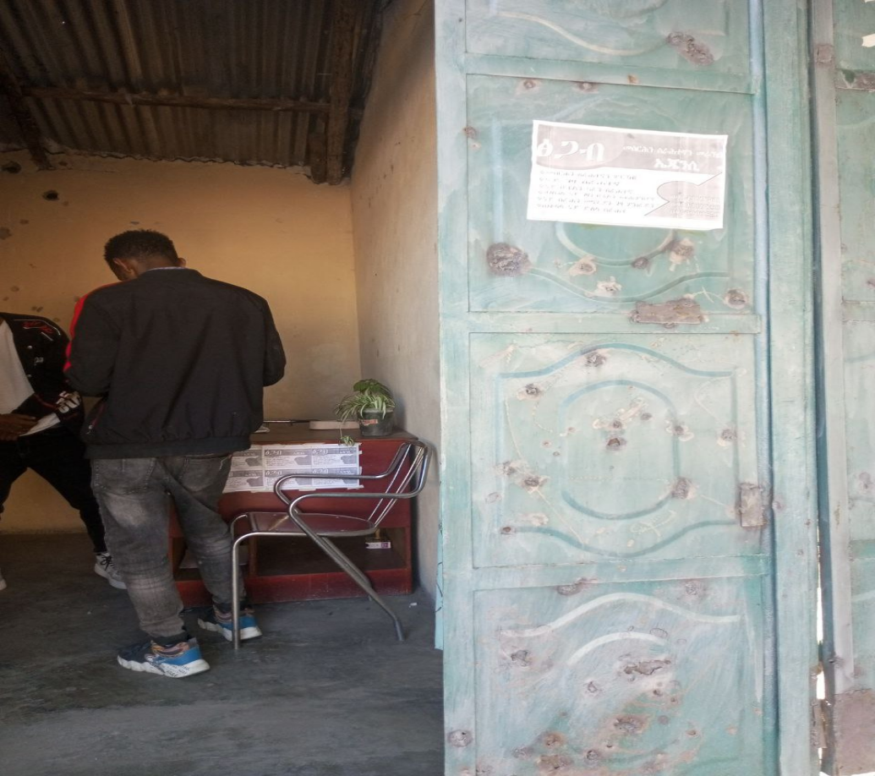

Figure 15: The Interview in the employment agency during requirement gathering

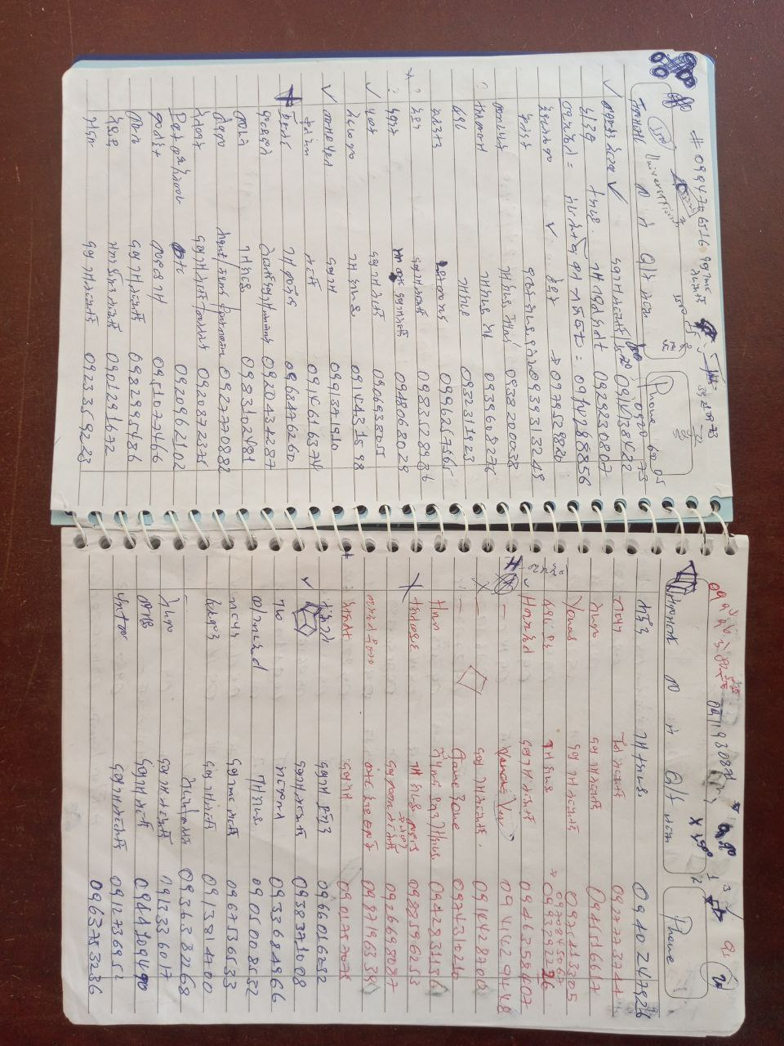

Figure 16 : Data storing method in the existing system



Figure 17 : The Contract Negotiation paper in the existing system